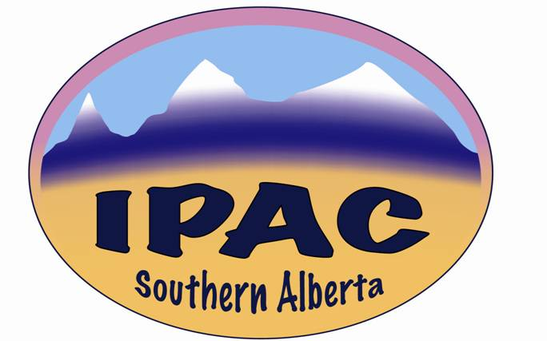

**IPAC – Southern Alberta**

**MINUTES**

**Date**: Wednesday, September 7th, 2022

**Venue**: Virtual

**Time**: 13:30 – 14:00

**Present**: Zaheeda Jessani, Kristine Cannon, Maureen Kano, Rhonda DeMarco, Kimberley Houde, Josephine Kalunga, Jason Morris, Blanda Chow, Dave Zettel, Lemlem Ghebreyesus, Ashley Shackleford, Kaethel Decker, Jennifer Ellison, Ilona Fibich, Lorinda Stuber, Isabelle Tremblay, Janeth Ty, Dione Kolodka, Jenine Leal

The President, Kim, called meeting to order at 1330.

**Education**

Rhonda Demarco gave a presentation titled: *Alberta EMS and IPC.*

A fantastic presentation that gave a full overview of EMS in Alberta. The scope and diversity that EMS covers was eye opening, and I would recommend that if you were not present please reach out to me (Jason Morris) and I can work with Rhonda if you have any specific questions.

**Business Component**

President’s Report

Nothing to report on executive reports. AGM is occurring.

The President had invited members to submit names of proposed nominees for all office positions. At this time no names have been put forward.

Treasurer’s Report

No new update. The Chapter treasury currently has about $15,000.

Ecolab Theme Competition

The theme for **2023** will be **Unmasking the Future**

We are expecting the announcement for submissions should be coming out soon.

However, in the meantime here is the winner of the **2022** EcoLab Poster Contest

2022 Theme: SPREAD PREVENTION – NOT INFECTION

[Ecolab Poster Contest | IPAC Canada (ipac-canada.org)](https://ipac-canada.org/ecolab-poster-contest)



Others

**Interest Groups**

There were no reports given on interest groups.

**Action Item for All members:**

Please let the IPAC-Exec know if there are any key items you would like to see in upcoming IPAC-SA meetings

**Next Meeting**

Next meeting will be on November 2nd at 13:30.

There being no further discussion items, the President closed the meeting at 14:00.